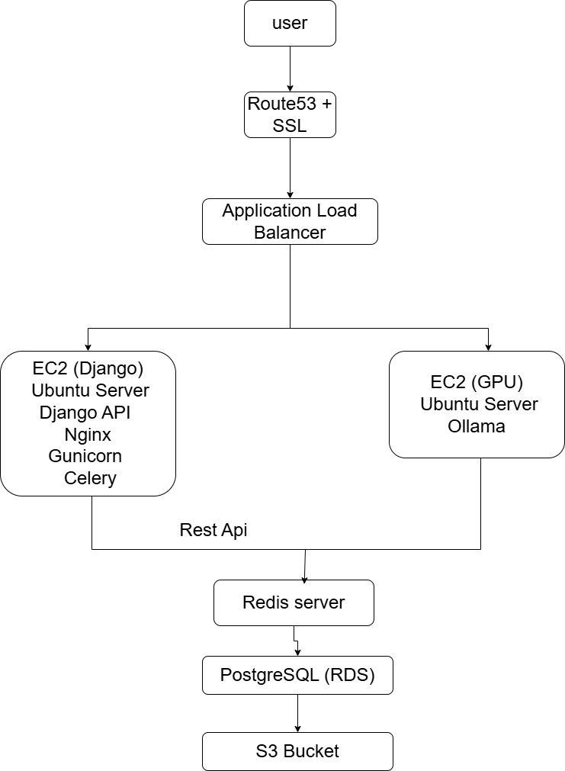

Overview
This architecture is designed to deploy a Django-based AI application on AWS with a dedicated GPU server for Large Language Model (LLM) inference. The design separates application processing from AI model execution, providing better performance, scalability, security, and maintainability.

1. User
The User is the client accessing the application through a web browser, mobile application, or API.

2. Route53 + SSL
Route53
Amazon Route53 is AWS's managed DNS service.
Responsibilities:
- Maps the application domain name to AWS resources.
- Directs users to the correct application endpoint.
- Provides highly available DNS resolution.
SSL Certificate
SSL (Secure Socket Layer) enables HTTPS communication.
Responsibilities:
- Encrypts data between users and servers.
- Protects sensitive information.
- Ensures secure API communication.
- Builds user trust through HTTPS.

3. Application Load Balancer (ALB)
The Application Load Balancer acts as the entry point for all incoming traffic.
Responsibilities:
- Receives requests from users.
- Distributes traffic across backend servers.
- Performs health checks on application servers.
- Improves application availability.
- Supports SSL termination.
Benefits:
- Prevents server overload.
- Improves fault tolerance.
- Enables future horizontal scaling.

4. EC2 Application Server (Django)
This server hosts the core business application.
Ubuntu Server
The operating system used to host all application components.
Django API
Django serves as the main backend framework.
Responsibilities:
- User authentication
- API handling
- Business logic execution
- File upload processing
- Database interactions
- AI request management
Nginx
Nginx acts as a reverse proxy server.
Responsibilities:
- Receives HTTP/HTTPS requests.
- Serves static files.
- Forwards requests to Gunicorn.
- Enhances security and performance.
Gunicorn
Gunicorn is the production application server for Django.
Responsibilities:
- Runs multiple Django worker processes.
- Handles concurrent user requests.
- Improves application performance and reliability.
Celery
Celery handles asynchronous background processing.
Responsibilities:
- Long-running tasks
- File processing
- AI-related jobs
- Scheduled tasks
- Batch operations
Benefits:
- Prevents request timeouts.
- Improves user experience.
- Allows large workloads to be processed efficiently.

5. EC2 GPU Server (Ollama)
This server is dedicated to AI model inference.
Ubuntu Server
Provides the operating system environment.

Why Use a Separate GPU Server?
Separating AI inference from the web application provides:
- Better performance
- Independent scaling
- Improved stability
- Efficient GPU utilization
- Reduced risk of application downtime
The Django server communicates with the GPU server through internal APIs.

6. Redis Server
Redis acts as the message broker between Django and Celery.
Responsibilities:
- Queue management
- Task distribution
- Temporary caching
- Session storage
- Real-time progress tracking
Workflow:
- Django submits a task.
- Redis stores the task in memory.
- Celery workers retrieve the task.
- Processing begins in the background.
Benefits:
- Extremely fast performance.
- Supports high-volume task processing.
- Reduces application latency.
7. PostgreSQL
PostgreSQL database services.
Responsibilities:
User Data
- User accounts
- Profiles
- Authentication data
- Permissions
Application Data
- Task records
- Job status
- Processing history
AI Data
- Chat history
- AI outputs
- Metadata
- Report information
Benefits:
- Automated backups
- High availability
- Automated patching
- Database monitoring
- Reduced administrative overhead

8. Amazon S3 Bucket
Amazon S3 is used for scalable object storage.

